OOP Project

# Related image**Project Implementation Report: Iteration 2**

CS 319 Object Oriented Software Engineering  
Eray TÜZÜN  
Group 1-I: Private Moon Inc.

Project Group Members

• Doğa Oruç – 21602022

• Çağrı Orhan - 21503102

• Fazilet Simge Er - 21602358

• Kaan Ünlü - 21602622

• Ege Turan – 21502441

Contents

**Project Implementation Report: Iteration 2** 1

1.0 Introduction 3

2.0 Design Changes 3

3.0 Lessons Learned 6

4.0 User’s Guide 7

4.1 System Requirements & Installation 7

4.2 How to Build 7

4.2.1 Running Through Source Code 7

4.2.2 Running Through JAR or EXE 7

4.3 How to Play 8

4.3.1 Offline Game 8

4.3.2 Online Game 9

5.0 Work Distribution 12

6.0 Glossary & References 13

# Introduction

The implementation of the project is almost complete with some sub-menu’s, custom map editor and connecting the multiplayer to the game being deficient. In addition, some difficulties of AI need to be improved. Hopefully, these features will be implemented, and the project will be complete by the deadline.

# 2.0 Design Changes

During the implementation report of the first iteration, we came up with following class diagram:

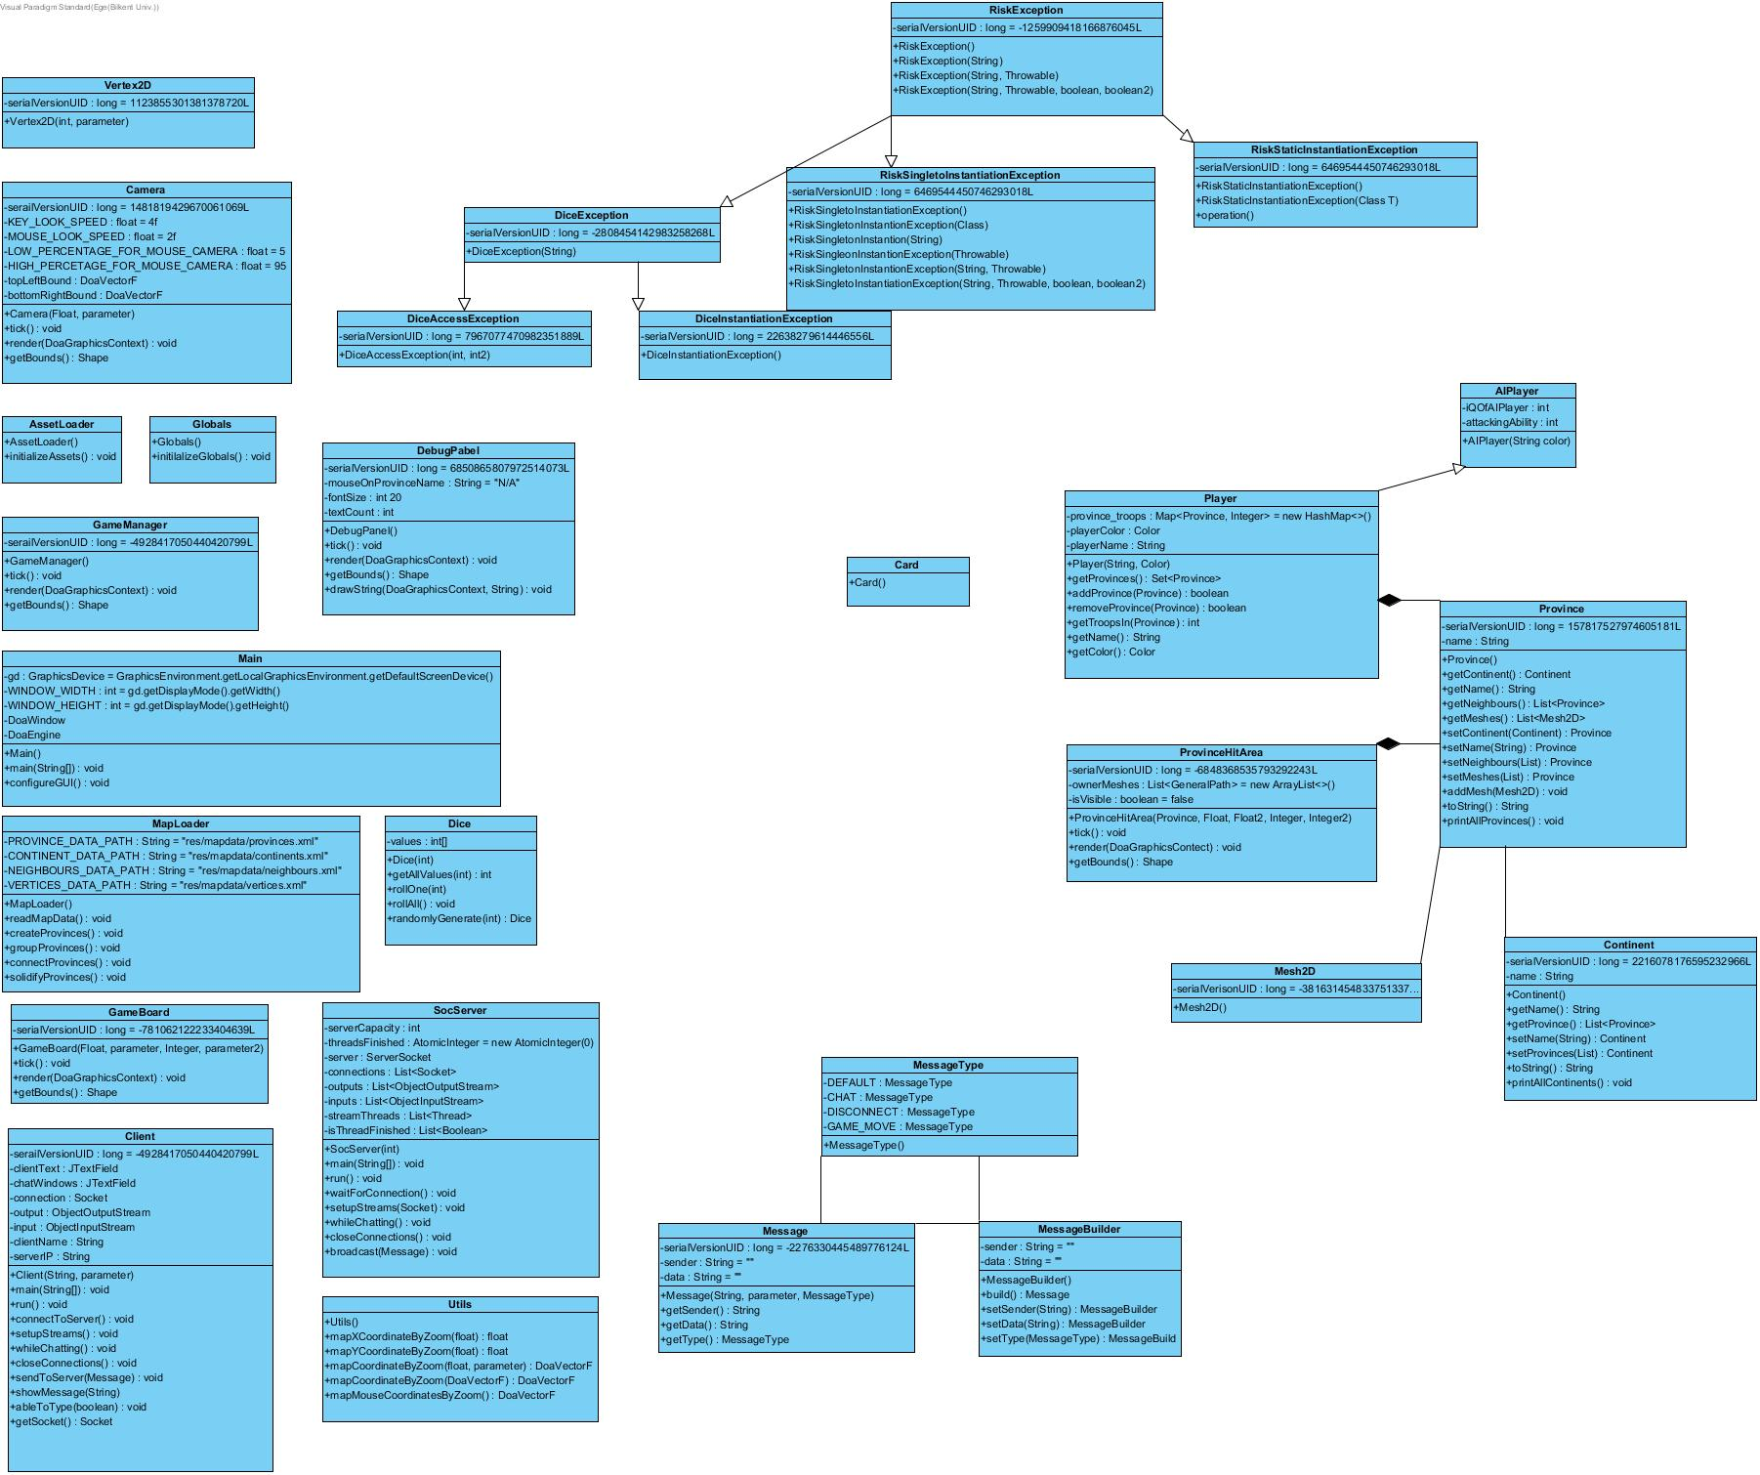

##### *Figure 1: Class diagram at the time of the first iteration implementation document*

As time went on and we fleshed out our design more, we changed and added some classes and added Exception classes. All of the exception classes use inheritance and handle one of the problems that we faced during the development process.

Secondly, we added the new MessageType and Message classes to improve communication and data transfer more efficiently.

Thirdly, we added ProvinceHitArea to determine the vertices of the province. ProvinceHitArea takes provinces and their vertex values, it determines the physical span of that province.

After changes in our project with new added classes, the class diagram transforms into following diagram:

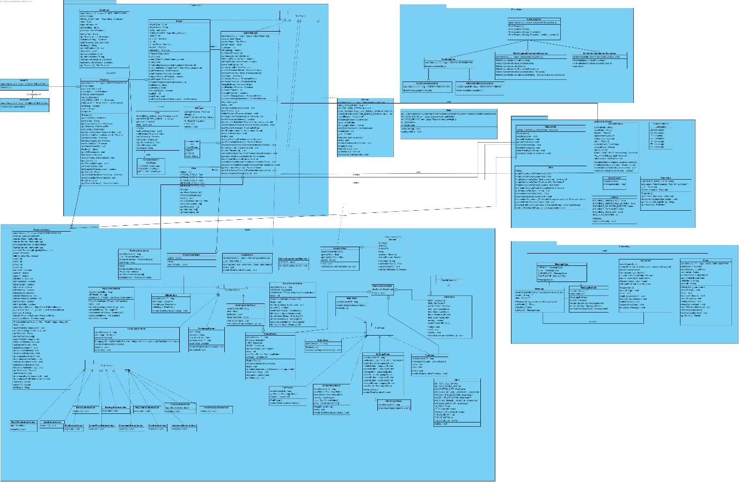

##### *Figure 2: Updated class diagram*

How system of the class diagram changed is that we have divided our class diagram into Game Logic, RiskUI, Networking,Loaders &Globals, and Exceptions. Secondly, we add some classes for Button Actions. These classes handles the works of the buttons.Also, we add new panels for the UI and we add new classes for image buttons which buttons had images on them and works as button.

Other change was about attacking province logic. Firstly, we implemented attacking province differently. First sequence diagram of attacking a province is as below:

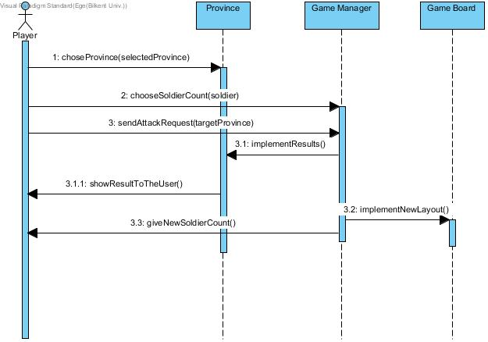

##### *Figure3: Sequence diagram for attacking province in the design report*

In this first design, we implemented how soldiers will be set by the user and how attack request will be sent.

The following is our final sequence diagram for attacking a province.

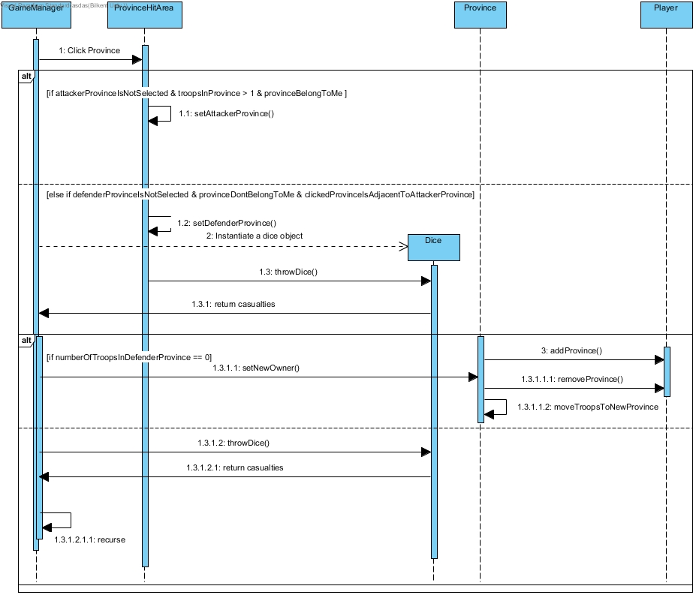

##### *Figure4: Updated sequence diagram for attacking province.*

We added how province will be removed from a user and how troops will be moved as well.

In addition, we changed our Language class’ design in order to ensure that language support works efficiently without waste of time. The early version of the Language class was reading the translated strings from the XML file. The problem was, Language class had to read the XML file of the current language every time when a user tries to change the language. Thus, we changed our design so that Language class reads all the languages while booting up the game and put the translated strings into a Map. So now, when a user wants to change the language, he/she does not have to wait for reading the XML file.

# 3.0 Lessons Learned

We encountered a lot of problems while implementing and designing this project. The first important issue was about lack of communication. As a group, we were meeting only two times a week. This caused disruptions in the project due to lack of sufficient communication. There were problems while bringing the parts of the project together. We decided to meet more often because it was obvious that something was going wrong. We've increased our group meetings’ frequency. Also, we have started to use the “Discord” app which is supplying free voice chat and screen sharing. We saw that more and instant communication can solve many problems. We started to do our jobs faster and with better synchronization. The solution process gained speed through communication.

Another issue was about disagreements. As it is known, the Risk is a board game and there is no single official version of the game [1]. Designing the game on a digital platform required many decisions about graphics and mechanics. At some points, we had difficulties in the decision-making process. When deciding on the mechanics and graphics of the game, different ideas were raised. Our solution was making assessments and trying to find out which one would look and feel the most impressive with the least amount of work, so that our final product would be as complete as it could be (and hopefully with the most extra features) by the final deadline. We were meeting at a common point after long reviews. This really helped us to maintain the decision-making process.

Another compromise example occurred because different group members are using different coding styles (such as how everyone placed their curly parentheses). When merging different individual’s codes into the same project, it was hard to read and write. We decided to choose the coding style by voting. Decisions were determined by the votes of the members of the group so that no one would resist the decisions. This provided a democratic solution to the discussions. We had set a consistent coding style that everyone will follow. This aims to increase the maintainability of the code.

We also realized the psychological effect of working as a group. The bystander effect occurs when the presence of others discourages an individual from intervening in an emergency. When an emergency occurs, everyone tends to put the responsibility on someone else. We encountered with bystander effect so much on the beginning of the project. Work distribution in advance of deadlines helped us solve this problem.

All in all, starting to work with a group can lead to many problems inside the group. We learned that a problem within a group can only be solved by within the group. We saw that synchronous communication, compromise, reviews, and brainstorming is essential tools for managing a group project.

# 4.0 User’s Guide

## 4.1 System Requirements & Installation

Risk can be run on any computer environment, since it will be released both as a JAR (.jar) file and an EXE (.exe) file after the last touches. To install the game, one should have either of the game’s executables, and simply run it.

## 4.2 How to Build

The game can be run in two ways:

### 4.2.1 Running Through Source Code

1. Open project’s source code in an IDE that has a Java compiler. You can find the source code on GitHub.
2. Make sure that the *res* folder and the *src* folder are inside the build path.
3. Compile & run the program.
4. A splash screen will be displayed while the game is being loaded.
5. The main menu of the game should appear.

### 4.2.2 Running Through JAR or EXE

1. Run the JAR (or the EXE) file by simply double clicking it.
2. A splash screen will be displayed while the game is being loaded.
3. The main menu of the game should appear.

## 4.3 How to Play

### 4.3.1 Offline Game

1. Run the game.
2. Select *Play Offline* from the main menu.

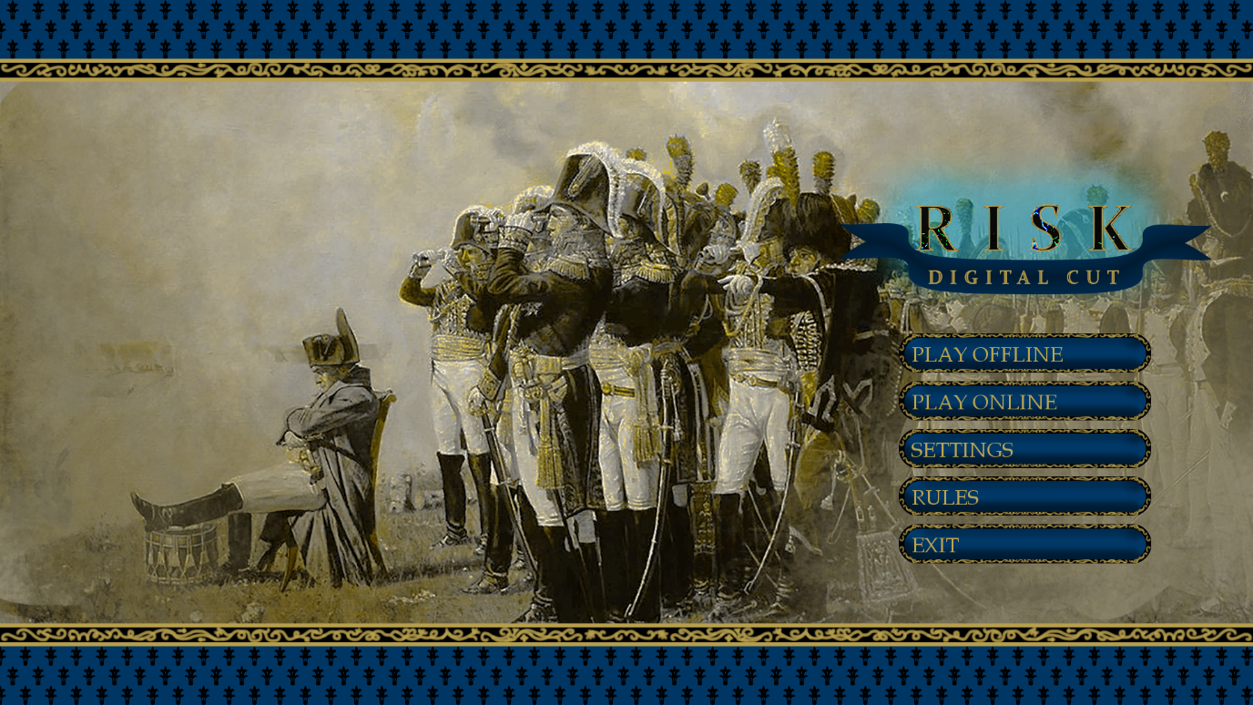

1. Configure the game and press *Play* button.

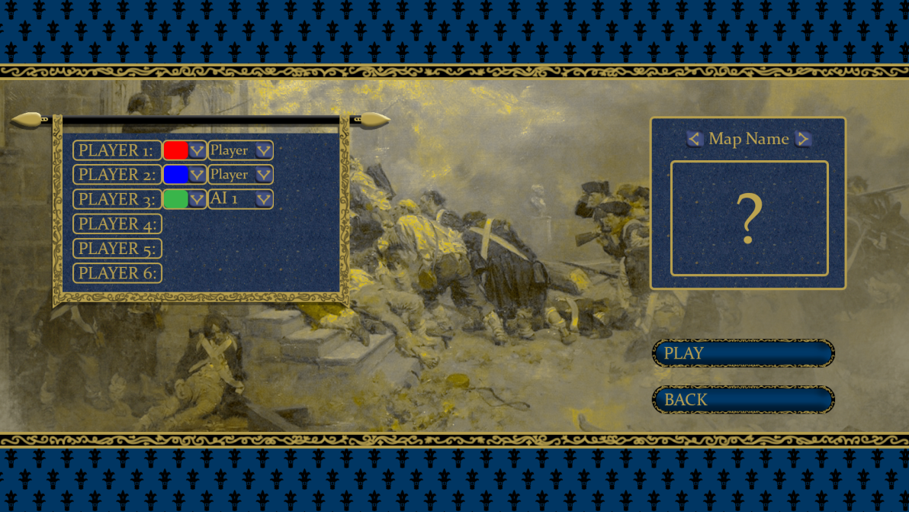

1. Enjoy the offline game.

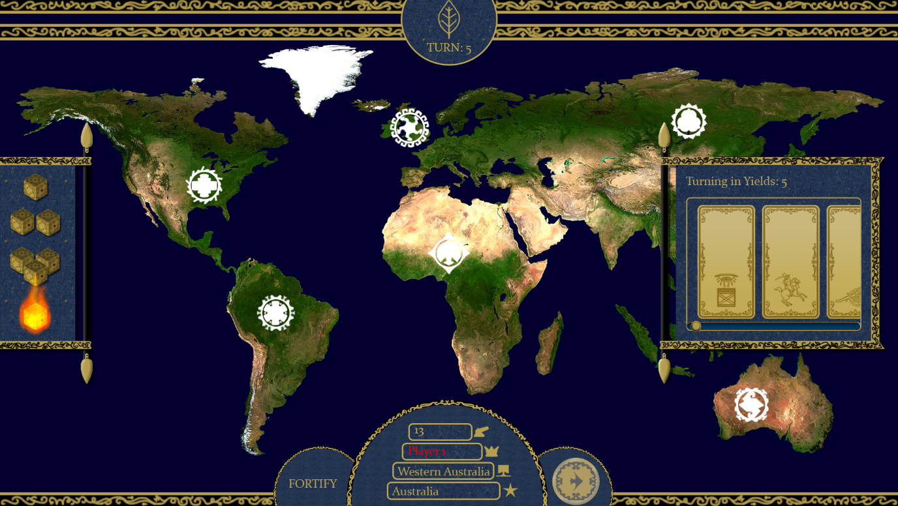

### 4.3.2 Online Game

1. Run the game.
2. Select *Play Online* from the main menu.



1. Choose either to be a host or a client. If you are a client, enter the ID of the host.

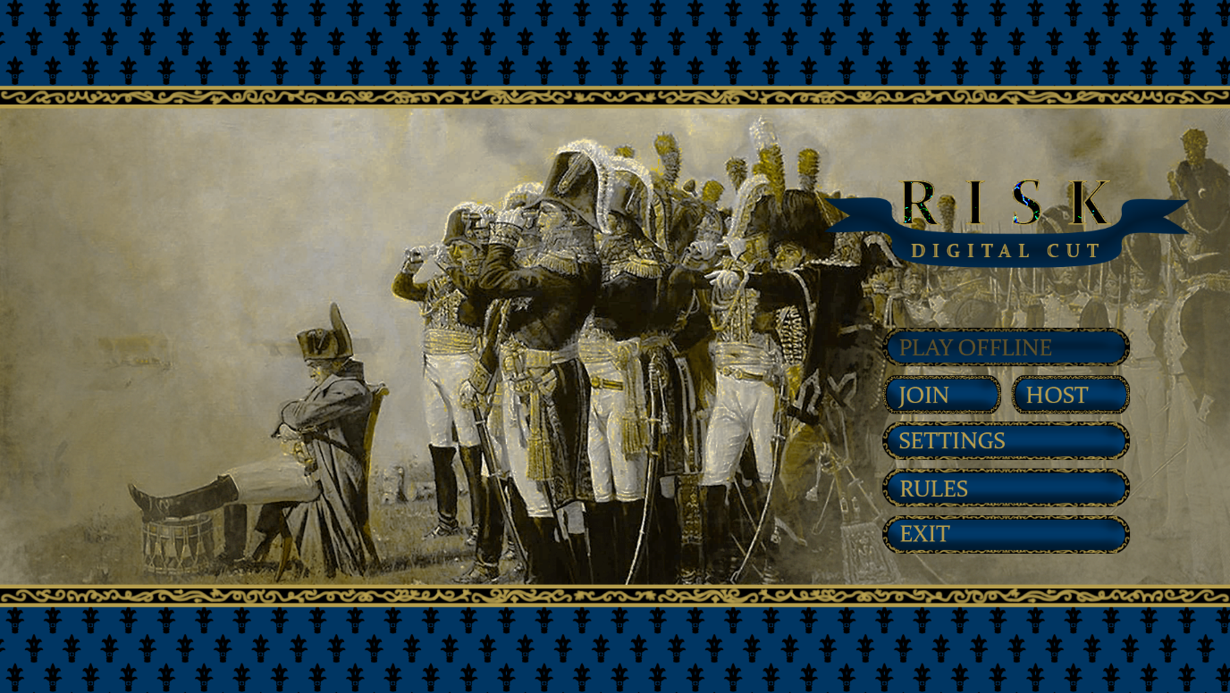

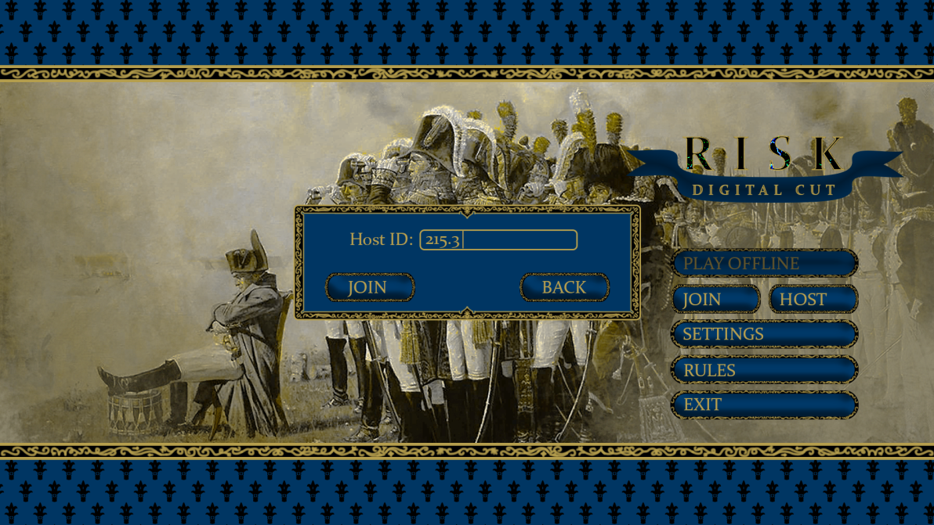

1. Configure the game and press *Ready* button.

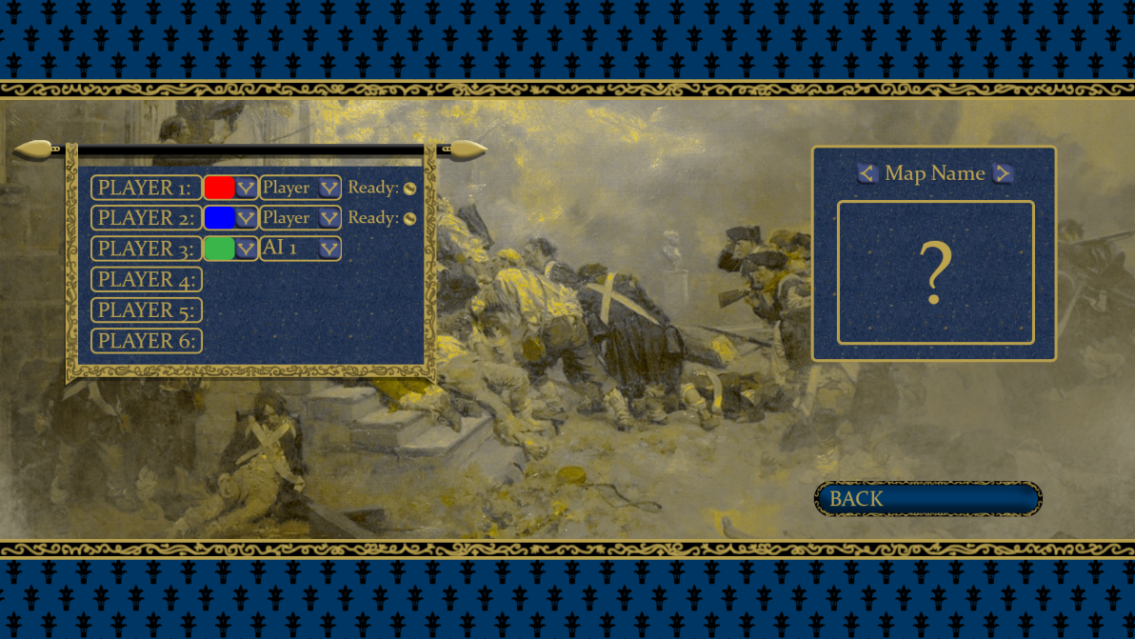

1. Enjoy the online game with your friends.



# 5.0 Work Distribution

Our group’s work allocation is as follows:

• Doğa Oruç – Lead Coder and Project Manager

* Revising reports
* Drawing sequence and class diagrams
* Implementation of all entity classes
* Implementation of multiplayer backend
* Implementation of UI (Roy)
* Implementation of game logic
* Implementation of game engine (DoaEngine)
* Implementation of localization module
* Implementation of XML reader
* Implementation of map support

• Çağrı Orhan

* Writing reports
* Drawing state and use case diagrams
* Implementation of localization module

• Fazilet Simge Er

* Writing reports
* Drawing state diagram
* Implementation of game logic
* Implementation of AI
* Creating maps/map data

• Kaan Ünlü – Lead Artist

* Writing reports
* Revising reports
* Drawing sequence diagram
* Drawing all sprites
* Composing music
* Finding sound effects
* Worked on the UI (Roy)

• Ege Turan

* Writing reports
* Drawing use case, sequence, state, activity and class diagrams
* Implementation of multiplayer backend and frontend
* Worked on the map support of the game
* Implementation save/load feature

# 6.0 Glossary & References

|  |  |
| --- | --- |
| [1] | Brilliant Maps, “27 Best Risk Board Game Versions Based On Real Player Reviews,” 28 August 2016. [Online]. Available: https://brilliantmaps.com/risk/. [Accessed 31 March 2019]. |